MEG noise
Moshe Abeles, Gonda multidisciplinary brain reaserch center
Bar Ilan University, Israel
Updates:
19-Jan-2009
28-Oct-2010

This is a summary of the problems with noise in our MEG.
A major problem is the instability in the types of noise we encounter.
- Line frequency interference. Worked well in the past but since 2010 we have problems.
- Low frequency noise at 12, 20 and (mostly) 24 Hz varies a lot from day to day and from measurement to measurement within the same day. It is not clear to me that we can do much about it except finding out ways to clean it with the aid of the REF channels.
- Transient noise – loud clicks from within the sensor’s hood are very disturbing to the subject and induce long-lasting “ringing” in several channels.
- High frequency (140-500 Hz) oscillations are found on multiple channels. This may not be a problem for clinical studies concentrating at frequencies below 100 Hz but are very bad for psychological and physiological scientific studies. They may be very bad also for prospect future studies of early diagnosis as is promoted by the Georgopoulos group.
- High (up to +/- 0.5) correlations in groups of channels that share the same SAD card

Below are more insights and details regarding these issues:
1. Line frequency interference
There are large lines at 50, 100, 150,… Hz. These were completely cleaned by providing a trigger which is hooked to the line AC and subtracting the average. In 2010 I discovered that this have only partial effect. I attributed this to the addition of UPS for the line-conditioner of 4D. So I added another trigger bit which was synchronized to 4D's AC line. However, it turned out that within 100 s. both trigs show exactly (~5000) cycles. This seemed implausible! I checked whether by mistake the UPS is not effectively used during normal line supply. But, the 4D line conditioner is definitely used, and functions so that continuously its line output is derived from its battery, which in turn is continuously re-charged. (This permits continuous supply in case of power failure, and power resumption before the UPS battery dies out.)
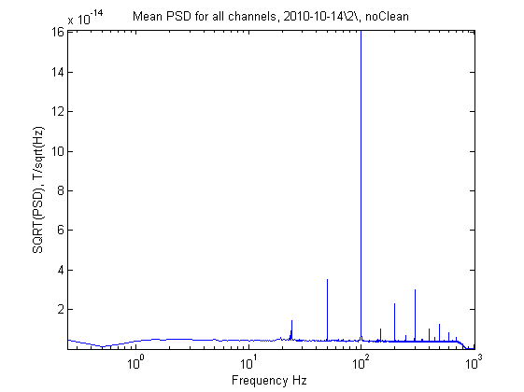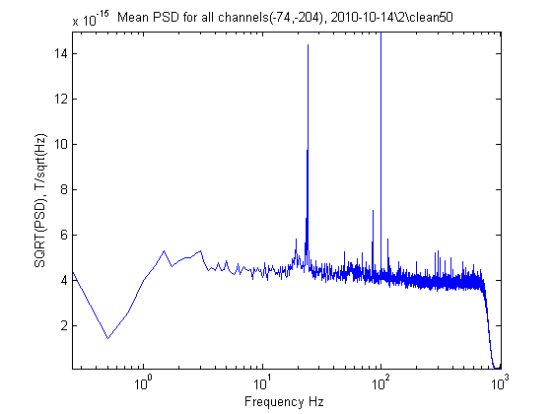
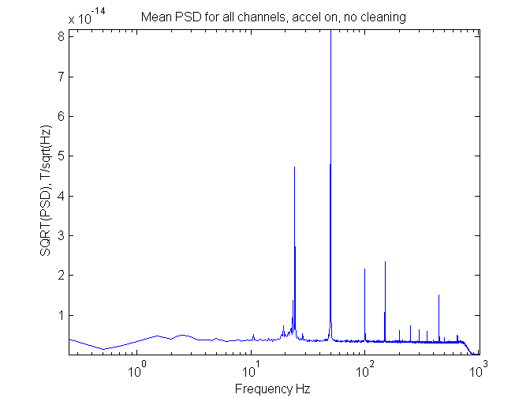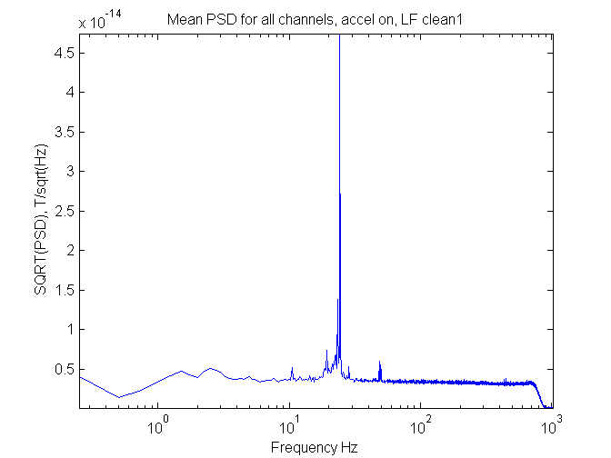

Figure 1.1. Comparingline frequency cleaning
Top – 14-Nov-2010
Bottom – 24-Nov-2010
Left – no cleaning
Right – LF cleaning with a "global" average
Note that on 14-10-2010 the LF artifacts are almost doubled relative to 24-10-2010

Figure 1.1 shows some data related to the issue of line frequency during measurements. The data for 14-Oct-2010 are data in which the LF cleaning did not work well. The data for 24-Oct-2010 are data for which the LF cleaning worked well (without any understandable external reason). Figure 1.2, shows data about the line frequency itself on the two dates. It also shows how did the time intervals between two line frequency triggers, one from the general building power and one from the 4D line conditioner change over time.

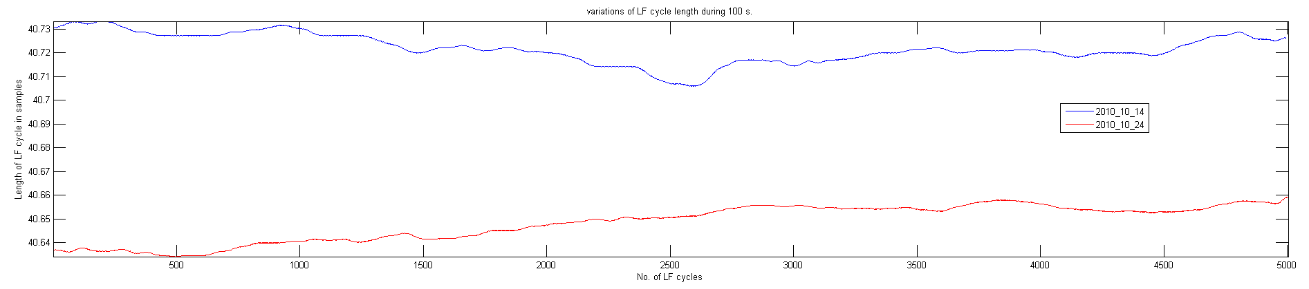
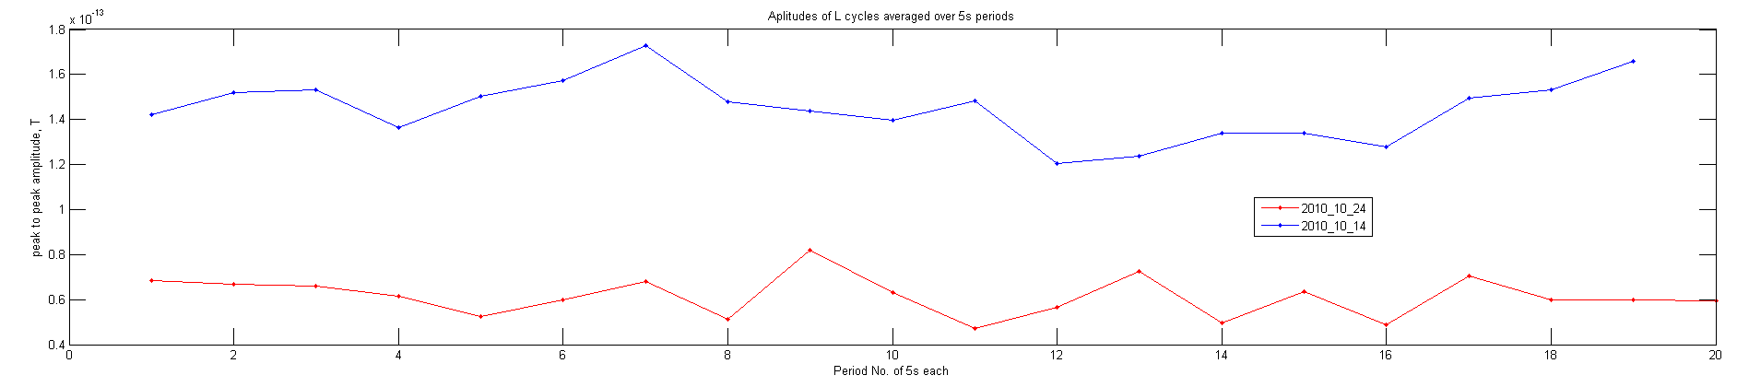

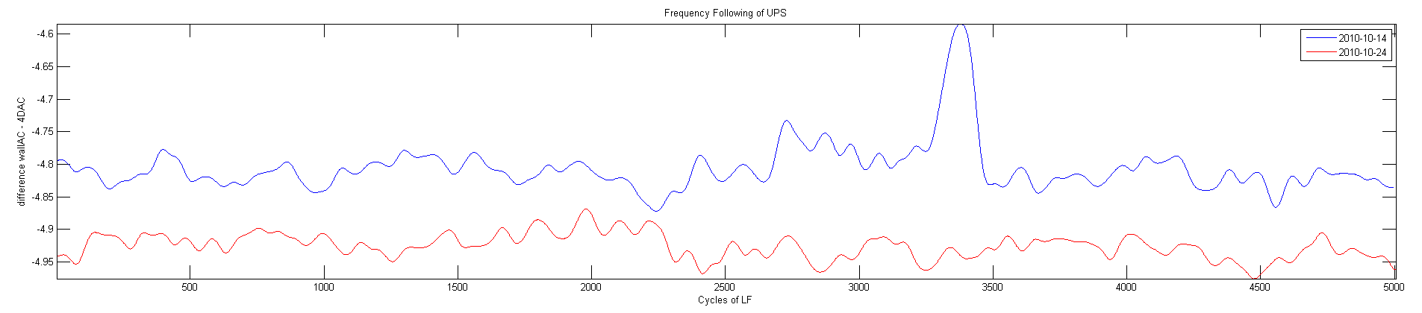
Figure 1.2 Line frequency modulation
Top – smoothed rate of mains LF trig.
Middle – peak to peak amplitude of the averaged 50Hz locked signal on channel A001.
Bottom – smoothed interval between the trig of mains AC and 4D conditioned line.
All curves are smoothed by convolving with a Gaussian having a std of 25 cycles.

From these curves it is clear that the LF drifts, although the range is small, like 1/1000 for 100s. On different days the LF may change considerably more. I thought the UPS frequency is controlled by an internal oscillator. If it was so then it would be impossible that I got exactly the same number of triggers from both lines over both days (although the total number of trigs per 100 s differed by about 4 for the two days).

An alternative explanation is that the UPS oscillator is driven by the mains oscillations. Then I would expect that the the phase difference between the two will be constant. This is not the case, as seen in Fig.1.2 –bottom. This may suggest that at points of sharp changes the locking between the two induced artifacts is lost, and then cleaning by one of the trigs is not efficient for cleaning the other.

However, for both dates breaking the data into pieces of relative stability, and pieces with fast changes, cleaning each separately – did not show any difference in the residual artifacts.

I tried improving the cleaning by interpolating the data 10 folds and computing the phase precession from cycle to cycle. That worked extremely well on artificial data with added 'artifacts' of fixed amplitude and period (but where the cycle lasted 40.7… samples), but did a very poor job on the actual data!

An improvement for 14-Nov-2010 was achieved when the average shape of the LF locked signal was not computed globally, but first computed for the first 250 cycles and then at every cycle it was updated by:

Y(n+1) = 0.996*Y(n) + X(n+1)/250,

Where Y is the average and X the data for the next cycle. This is equivalent to updating the artifacts with a time constant of 173 cycles. The weak point is that the residual of true MEG activity acts like 'noise' on top of this average. Such cleaning procedure would add 7.6% of noise to the ongoing MEG activity.

See appendix C for more details on the effects of recording conditions on the 50 Hz artifacts.

2. 24 Hz and other low frequencies.
The large 24 Hz artifacts were reduced after the arms of the gantry were replaced, but never went down completely. Now they are back up. 4D managed to reduce these much by concentrating the on-line weights on the low frequencies However:
- These do not clean this artifact completely.
- With these weights the average noise level over all the MEG channels at higher frequencies (100 and up) is way above the specs (they are now ~8fT/sqrt(Hz)).
The claim that although the residual 24 Hz artifacts are below the level of 24Hz in real MEG signals is true. However much of the studies on cognitive processes relate to coherence in this frequency range. A common 24 coherent signal on many channels is bound to distort the true dynamics of such coherences in cognitive tasks.

We wish to stress that the high spectral noise and the 24 Hz noise can be cleaned by other schemes. For example M. Abeles developed a scheme of using a different set of cleaning weights for different frequency bands which cleaned these noises completely (henceforth referred to as MA cleaning). Fig. 2.1 below illustrates this.

One can see that the high noise at frequencies above 100 Hz with 4D cleaning (blue trace in Fig. 2.1) is introduced by cleaning by looking at Fig. 2.2. It shows the PSD when recording was done with no on-line cleaning (neither analog nor digital weights applied). Fig. 2.2 shows also that the very sharp peaks at 140, 270, 460 Hz seen in the red trace of Fig. 2.1 are already in the raw MEG (blue trace in Fig. 2.2). MA cleaning reduces them somewhat but not completely.

While MA cleaning shows that the noise problems seen can be cleaned by appropriate subtraction of the REF channels, the MA cleaning cannot be useful because it is done outside the MSI framework (in MATLAB) and thus the MA cleaned signal cannot be used in any available source localization software. Further, as there are different set of weights for every frequency band, it is not clear that source localization can take them properly into account.

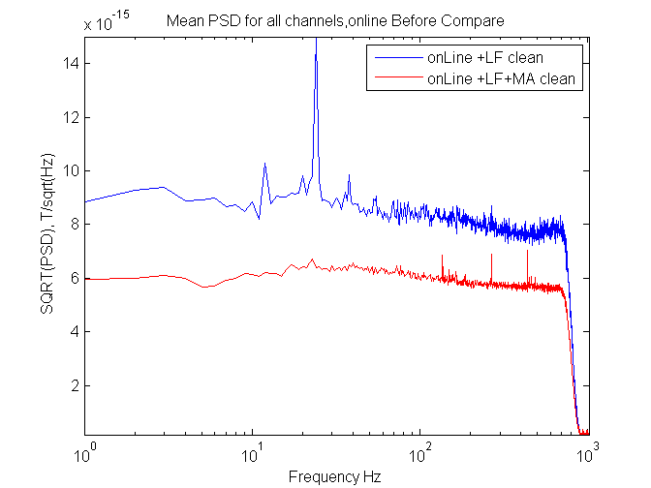

Figure 2.1. Mean PSD for all MEG channels with no subject in the MSR.
Left – using 4D analog and digital weights. Right – Using MA method.
In both cases the Line Frequency (LF) was cleaned out by recording a trigger which was synchronized to the power line. Note that the abscissa is plotted on a logarithmic scale to allow for comparing band-width of power. PSD was computed at 1 Hz resolution.

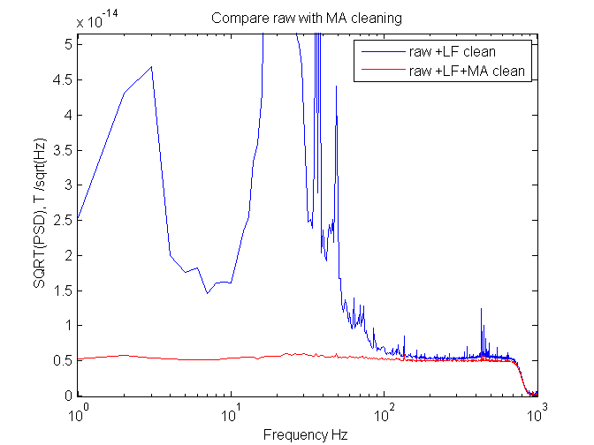
Figure 2.2. PSD for raw MEG signal.
Neither analog nor digital weights were applied. LF cleaning was carried before computing the PSD of the raw signal (blue) or cleaning by the MA method. The top of the plot was clipped to get a better resolution of the PSD at high frequencies.

After 1-Nov-2010 I tried to further improve the MA cleaning by keeping the frequency bands small also at high frequencies. So now the cleaning is done in bands:
[1-4, 4-8, 8-16, 16-32, 32-48, 48-64, ... 0.9*samplingRate/2].
That improved further the noise level at high frequencies.

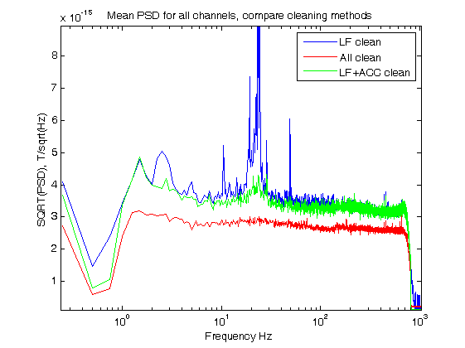
Figure 2.3. Comparing cleaning methods
Same data as in Fig. 2.2, but the red trace uses the new frequency bands for cleaning. The peak of the 24 Hz artifact in the blue trace is chopped off.

See appendix C for more details on the effect of acceleration cleaning.

3 . Problems with individual channels.
Several individual channels have problems of either high noise level or oscillations in some well defined ranges. These are illustrated below. The individual PSDs of each of the 248 channels was examined and the problematic channels were picked up. Their PSDs are given in Fig. 3.1.

In this figure each group of channels is plotted twice once (on the left) as came after analog and digital on-line cleaning and as came after MA cleaning (on the right). The top pair illustrates channels that look “OK”. The on-line channels settle at 6-8 fT/sqrt(Hz) the MA cleaned at 4-5.5 fT/sqrt(Hz). Note that large peak at ~24 Hz on the on-line cleaned signals. There is also a small but clear sharp peak for channels A13, A18 and A19 at 136Hz and 436Hz. These are not seen in the left panel because the higher noise masks them.

The middle panels show channels with high level of background noise. Channels A61 and A62 are way too high. But channels A42, A71, and A127 are also very high.

The lower panels show channels with oscillations at some specific frequencies. A187 , A207, and A205 at low frequencies. As these could not be cleaned by the REF channels (also in the MA method), I must assume it is something particular for these channels (may be a loose part in them?). Channel A236 shows HUGE oscillations at 268 and 279 Hz. Cannel A12 is flat and is plotted there just for comparison with the others.

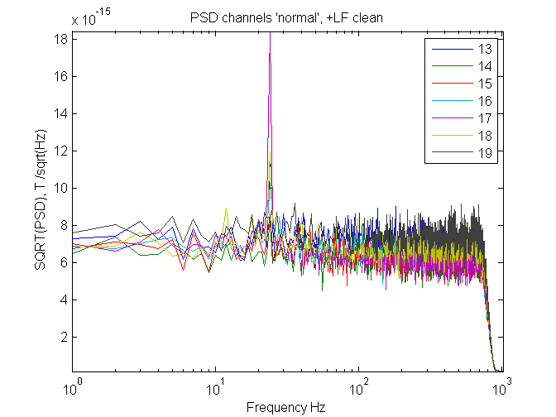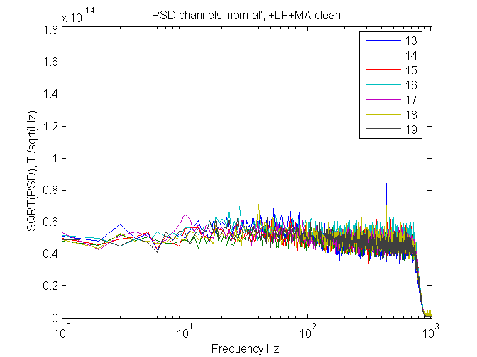

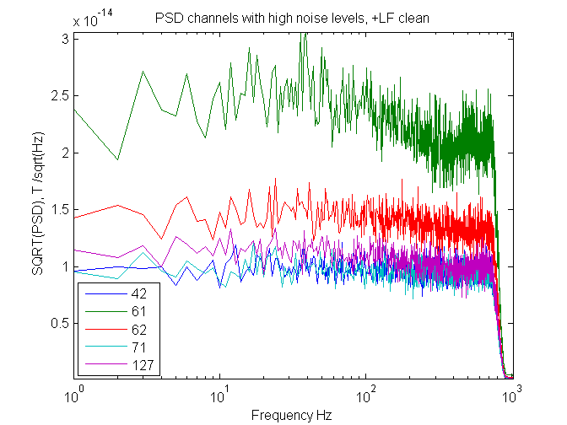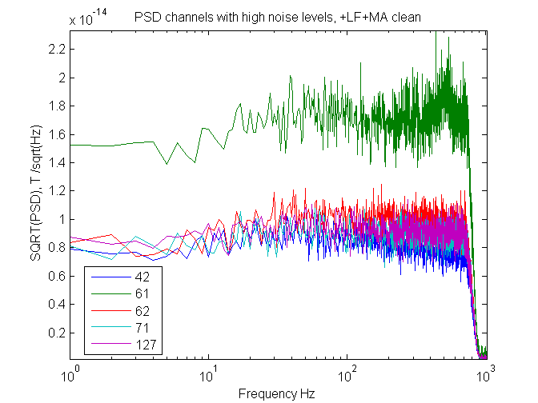
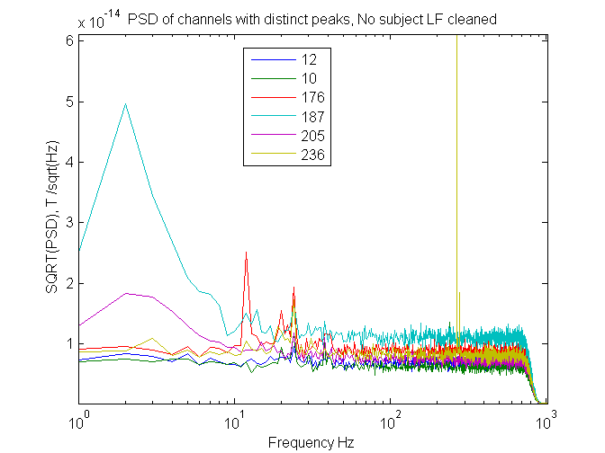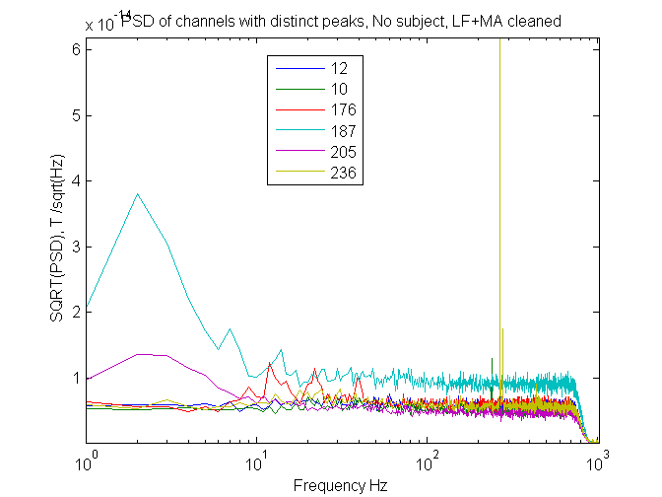

Figure 3.1. PSD of problematic channels.
Left – After cleaning with 4D on-line weights. Right after MA cleaning. LF was cleaned from all channels before computing their PSDs. PSDs were computed with 1 Hz resolution. The numbers in the “legend” boa are the MEG numbers (e.g. 10 means A10).
Top – a few “good” channels, for comparison with problematic ones.
Middle – Channels with high noise in the range of 10 to 25 fT/sqrt(Hz). Note the different scale s on the ordinate of the left and right plots.
Bottom – Channels with peaks at specific frequencies.

Some of the oscillatory channels were fixed in the maintenance immediately after 4D collapsed. Squids were replaced and some of them were found to be loosely attached to the hood.

I strongly suspected that these 24 Hz oscillations are due to water pumps on the roof. Therefore we ordered a survey by Dynamica Design Co. While they measured the accelerations at various points, I found that the measurements on the gantry may be used to reduce the 24 Hz artifacts almost completely. Figure 3.2 illustrates this.
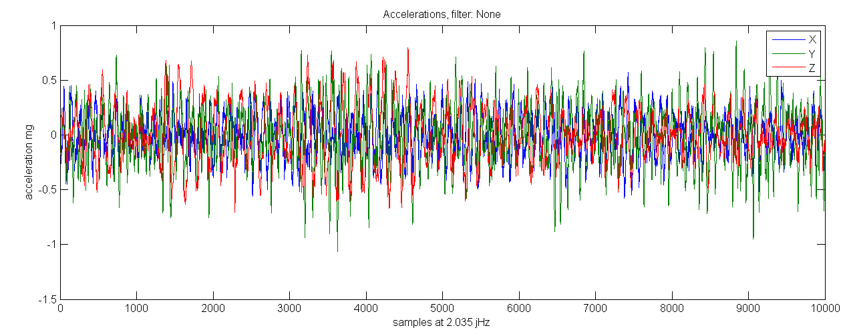
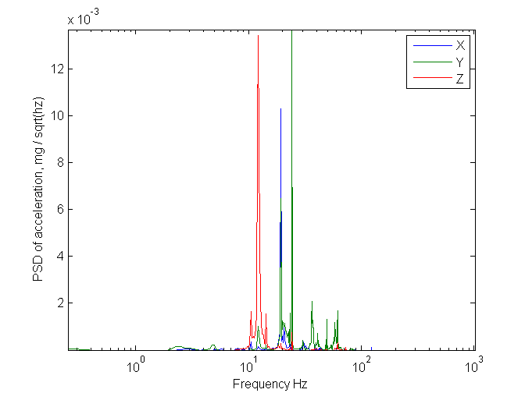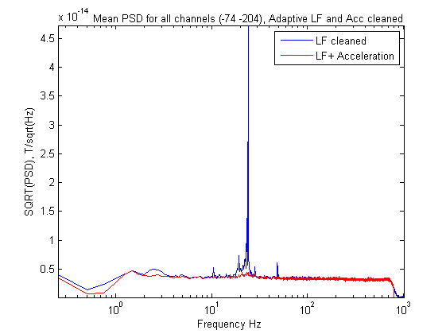

Figure 3.2 Cleaning the acceleration artifacts.
Top - a short piece of the acceleration in the X, Y, Z directions. Accelerometers were glued to the gantry.
Middle-left - the PSD of the accelerometers
Middle-right - Mean PSD before and after cleaning the acceleromoters signal. (Channels A74 and A204 were excluded from the mean.)

4. Correlations among channels.
Groups of channels showed high level of correlations among them. To be sure that they are not due to anything introduced by cleaning with the aid of the REF channels, I used raw data (without analog or digital weights), and after eliminating the LF interference filtered them above 150Hz and then computed the 248X248 correlation matrix. Fig. 4.1 show the distribution of correlation coefficients with channels A1 and A184.

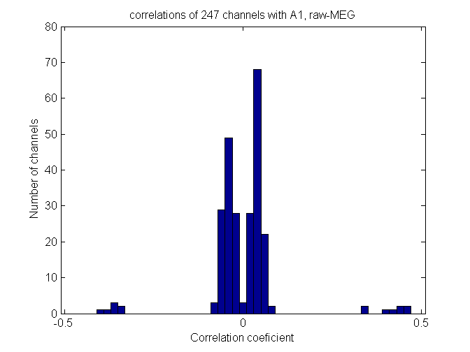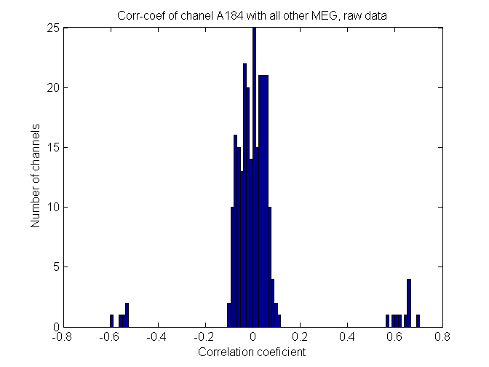

Figure 4.1. Correlations with A1and A184
Left – for A1. Right for A184
Only data after hi-pass above 150 Hz was considered for both histograms.

The 15 positive or negative outliers in each histogram are all within the same SAD card as the reference, #4 for A1 and #13 for A184.

In an attempt to find whether the excessive correlations have to do with the physical structure of the cables or the SAD card, we chose A184 and A1 as both are in position #13 on their respective SAD cards. Both SAD cards have only MEG channels on them.

Postive and negative high correlations ordered by position on SAD card:
A1: -1 1 1 1 -1 1 -1 1 -1 -1 1 1 NaN -1 1 -1
A184: -1 -1 1 -1 1 1 1 -1 1 1 1 -1 NaN 1 1 1
The similarity is minimal. Only (5 out of 15) channels show the same sign. Also the channel in position #14 which shares the same IC with the channel in position #13 have opposite types of correlations on the two cards. Plotting the physical positions of the negatively and positively correlated channels does not show any common geometrical architecture.

I shuffled all the rows and columns of the 248 by 248 correlation matrix so as to bring all channels with high mutual correlation together. This was done in a “greedy” way. First all channels with very high (positive or negative) correlations with A1 were shuffled so that they occupy the top left corner of the matrix. Then the next non-shuffled (A3) channel was used as pivot for collecting near it all channels with high correlations and so on. The result is shown in Fig. 4.2. One sees that the channels could be parsed into 18 groups. The group membership corresponds exactly to the 18 SAD cards in our system.

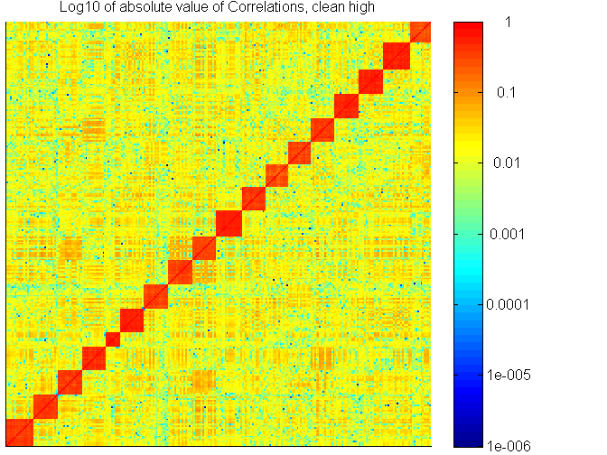

Figure 4.2. Correlations among all possible 248X248 pairs of channels.
The channels were reordered so that channels with high correlation (|r|>0.16) will be neighbors in the matrix. Correlations on the diagonal are 1 by definition. The matrix is symmetric by definition. Note that the color scale is logarithmic to provide high dynamic range resolution. Smaller squares are for SAD cards with several REF channels on them.

Thus the problem is definitely electronic! However the comparison of correlations in card #4 and #13 above shows that is not a problem of simple crosstalk (may be fluctuations in the carrier frequency generated on each SAD card.

MA cleaning of data reduced the small correlations (near 0) but did not affect the outlying side lobes.

The analysis was repeated for 2010-10-26 in which several recording conditions were available and CF cleaning was improved and Acc cleaning added. One question to be asked was whether the analog and digital weights cleaning add correlations. For each condition I compared two histograms of correlation coefficients. One for the entire data (1-800 hz) and one when the data was hi-passed (150-1017), assuming that the latter does not include any inductances from outside the MSR. Figure 4.3 shows the histogram when both Analog and Digital Weights were used during recording.
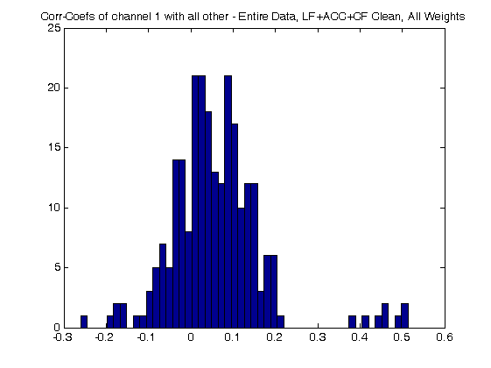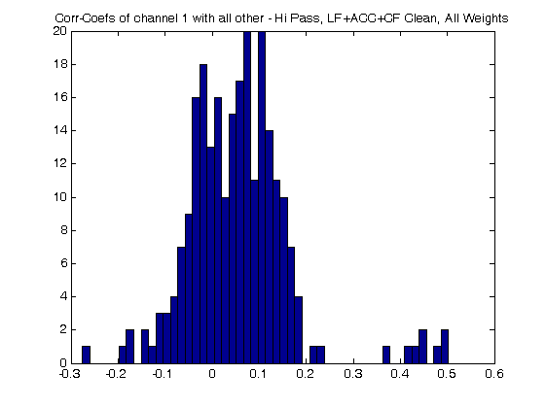

Figure 4.3 Correlations with channel A1.
Left – wide band.
Right – High – pass only.
Digital and analog weights were used. Cleaning was by Line frequency, Acceleration and FFT in multiple bands. Channels A74 and A204 were excluded.

Clearly most correlations are in the range of +/- 0.2 but a few are near -0.3 and +0.5. While the details are different the general picture is the same for both wide band and hi-passed data.

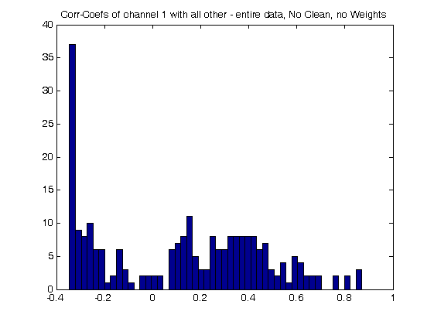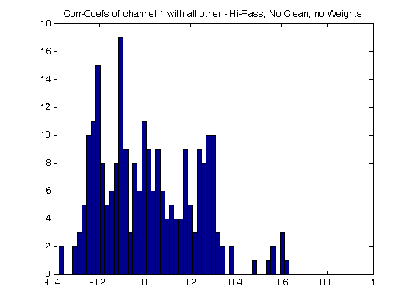
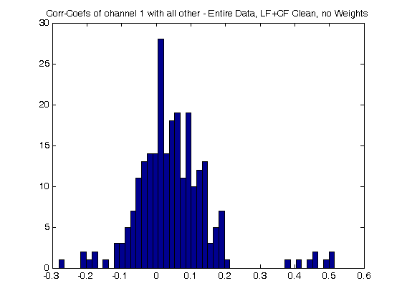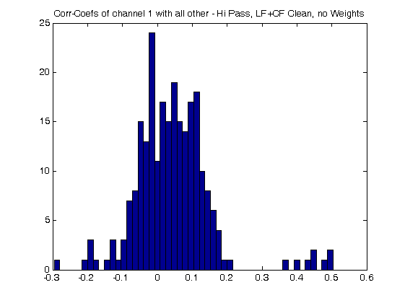
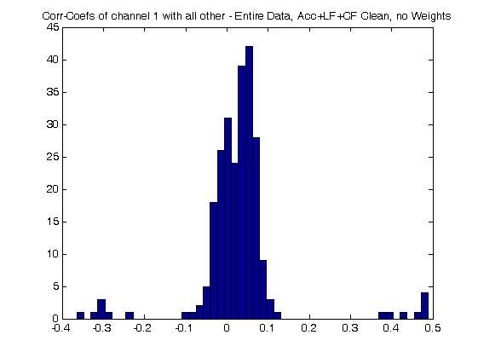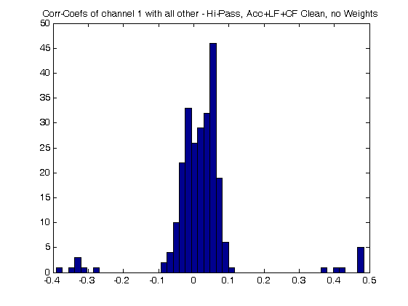

Figure 4.4 Correlations with Channel A1
In all the histograms data was collected with no weights.
Left – wide band.
Right – High – pass only.
Top – no post-cleaning
Middle – Lf and FFT cleaning but no acceleration
Bottom – also acceleration was cleaned

What are the effects of using analog weights only? Figure 4.5 shows that. It also shows the effect of FFT cleaning on the correlations.
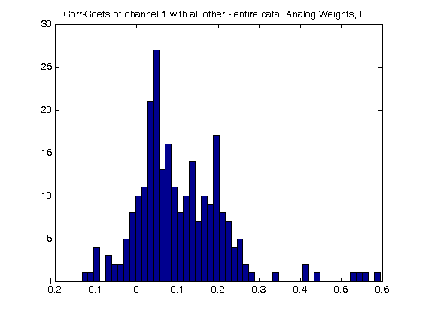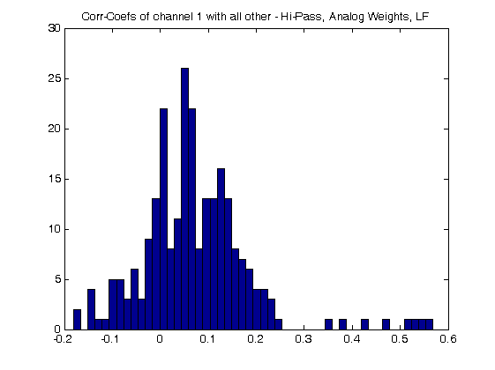
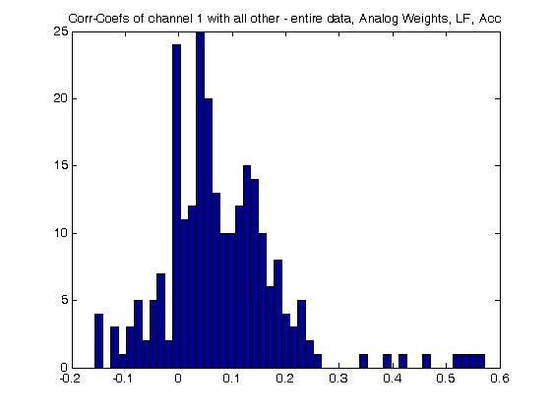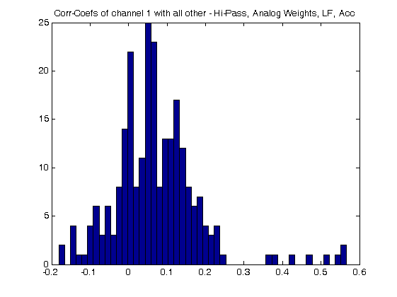
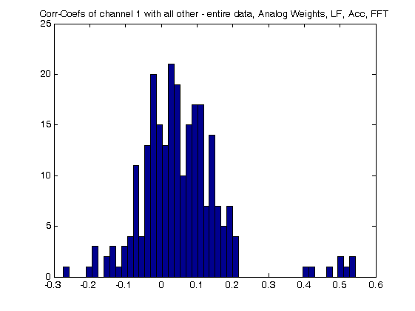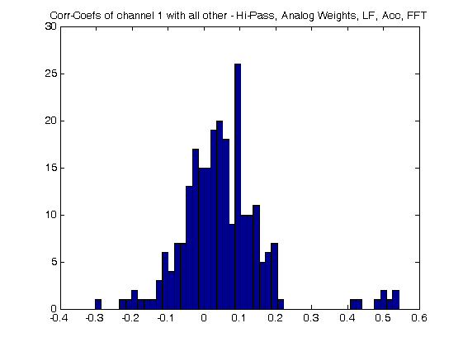
Figure 4.5 Correlations with Channel A1 with Analog weights only
All histograms are derived from the same data where only analog weights were used.
Left – for all frequencies
Right – for high-pass data (150 Hz and above)
Top – Only Line frequency cleaned
Middle – Line frequency and acceleration cleaned
Bottom – Line frequency, acceleration, and FFT cleaned.

The negative correlations are low when no cleaning (except LF) were done. The large positive correlations are not affected by cleaning. The positive tail of the central peak is trimmed by cleaning but the negative tail of this central peak is expanded. However one has to remember that the PSD is reduced by about 2 fold by FFT cleaning so that even if the correlation coefficient is increased a little its covariance is reduced. That means that the common noise component is reduced!

Conclusions:
- None of the conditions substantially changed the high negative and positive correlations of a few channels.
- However FFT cleaning reduces the covariance of these channels.
- Both hi-pass and wide band contain the few strong correlations.
- Best results were achieved when no weights were used and all the off-line methods were used. (Although the PSDs look better when weights were used.)

Appendix A. LF cleaning
Lf cleaning is done in the following way. An attenuated power-line is fed to a discriminator that produces a TTL signal locked to the line cycle. The mean signal for each cycle is computed. This mean is aligned again on every trigger mark and subtracted from the channel. Thus the “exact” shape of the line interference including harmonics is subtracted from each channel. But original MEG data which happen to be near the line frequency are not affected. Indeed, when the power spectra before and after LF cleaning 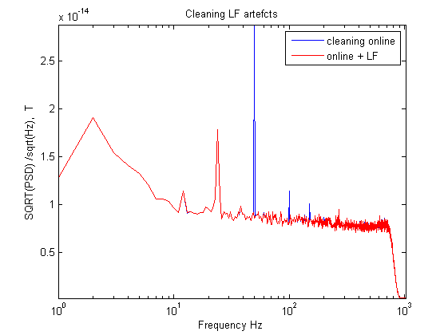
Figure A1. An example of cleaning line frequency artifacts.
20 s of recording with no subject in the MSR. PSD of each of the 248 channels was computed with a resolution of 1Hz. The square root of the mean of all 248 channels is shown. Blue – the mean PSD of the data before removing any wave-shape which was locked to the Line Frequency. Ref – the same after cleaning the wave-shapes locked to the LF. The red trace overlaps the blue one except at 50, 100, 150, and 200 Hz.

Fig. A1 shows the effect of such cleaning on 20 s of ‘noise’. Note that there are no notches at 50, 100, … but the cleaned PSD is at the same level like for the frequencies around it.

If the data is ‘epoched’ then only LF cycles which are fully available in each epoch are used for computing the mean wave-shape locked to the LF. The pieces at the end or the beginning of each epoch is cleaned according to the time elapsed from the last LF mark before the end or the first LF mark after the beginning.

Appendix B. MA cleaning
Prinincipal Components (PCs) of the REF signal are computed. The 16 eigen vectors with highest eigen values cover .995 of the total variance and these are used as PCs for further processing. (Update 18-Jan: with 22 eigen vectors a little bit better cleaning is achieved so from now I use 22 PCs.)
Cleaning of MEG is done in chunks of ~40,000 or 80,000 samples (for Windows or Linux). If the data is ‘epoched’ each epoch is shifted up / down so that its start is at the same level as the tail of the previous epoch. Chunks are redefined so that they start / end on epoch’s boundaries. FFT of the MEG and PCs is computed and divided into 9 frequency bands: 1-4, 4-8, 8-16, 16-32, 32-64, 64-128, 128-256, 256-512, and 512 – maxF. For each range a set of 16 (22) coefficients are computed so that subtracting the PCs from the MEG result in minimal power at that range. Then all the cleaned FFTs are concatenated and converted back to functions of time. To avoid sharp jumps every 40,000 (or 80,000) samples, the initial chunks are overlapped by 40 samples and the cleaned signal gradually shifts from the values of the tail of one chunk to the head of the next. This is done separately for every MEG channel. Figs 1 and 2 show the effect of such cleaning.

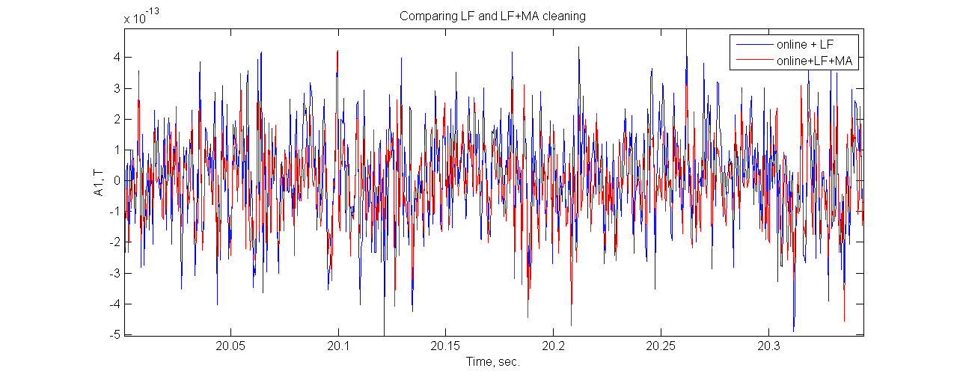

Figure B1 Comparing traces
330 ms of activity in A1 (arbitrarily chosen) is shown after cleaning the LF artifact only (blue) and after also applying MA cleaning. The slower undulations are kept but the level of sharp up/down fluctuations is reduced. This is a little piece of the data used for computing Fig. A1.

Fig B1 illustrates the effect of MA cleaning on noise recording. Fig. B2 shows the same comparison for real MEG recordings (MA 04-Jan-09).

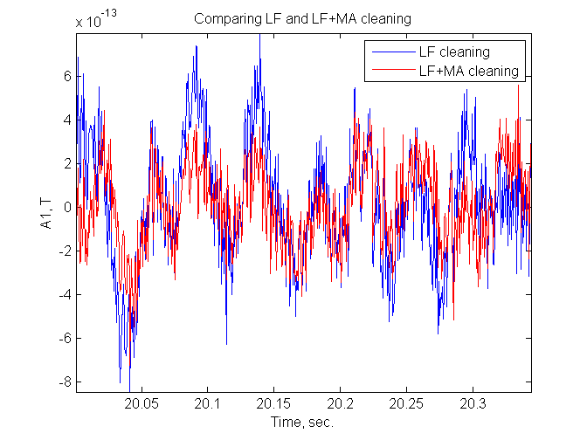
Figure B2. Comparing cleaning for real MEG data.
Same as in B1 but for real MEG recordings.

Appendix C. Noise under different conditions

Yuval measured 2 minutes stretches of data without a subject under various conditions, as described below:

No Weights scans:
run 1 screen far
run 2 is the standard:
the Eye Tracker Camera was off,
Accelerometer on, screen in it's position,
trigger (256) source line 21 (regular line near the DAS)
run 3 Eye Tracker camera on
run 4 coils on head disconected and removed
run 5 source of trigger line 38.
note that here (before run 5) I broke the 50 trigger gadjet and used the other one in it's
place, keeping it on 256.

Analog weights
run 1 identical to no weights
run 2

Digital weights
run 1 identical to no weights
run 2, I observed 100Hz artifact by eye so ran another run.
run 2 identical to no weights run 2, less artifact was seen this time.
run 3 the accelerometers were turned off, artifact visible.

No weights #2
Un easy about the lack of clear no weight comparison with and without accelerometers I ran 2 more standart acquisitions
run 1 accelerometers on
run 2 accelerometers off

On several of those I ran the following:
- measuring power spectral density on the data as is. Sensors 204 and 74 had problems and were not considered.
- cleaning the Line Frequency with the aid of line-locked trigger on bit 8 (256) of the trigger channel, using the Adaptive Mode. This was done in Matlab on 100 s of recorded data.
- Cleaning Line Frequency and X-Y-Z acceleration on the gantry by the program createCleanFileF.
- As 3 above but also cleaning the REF channels from the MEG channels within multiple frequency bands: (0.1-1, 1-2, 2-4, 4-8, 8-16, 16-32, 32-48, 48-64,... ), with band width of 16 Hz all the way up till ~900.

Results.
Line Frequency artifacts on some conditions may be estimated by looking at the 50 and 100 Hz lines in the spectra of Figure C.1.
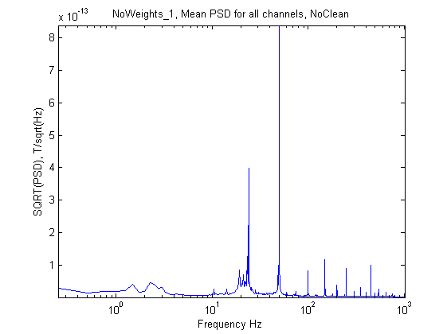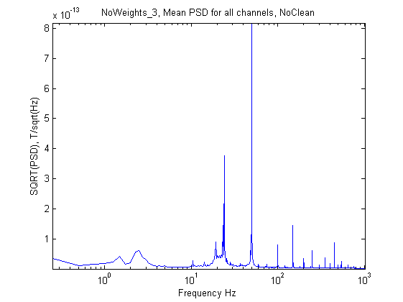
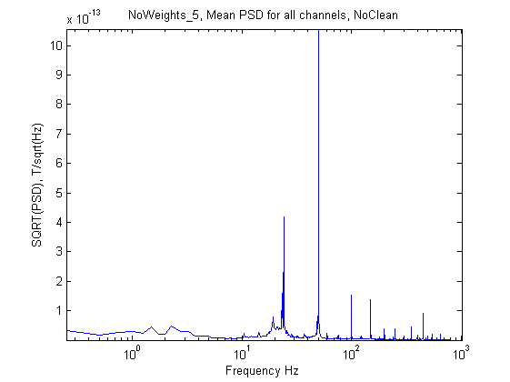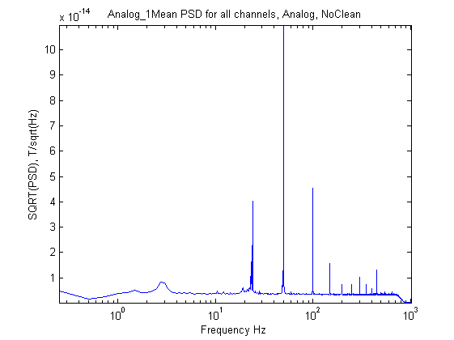
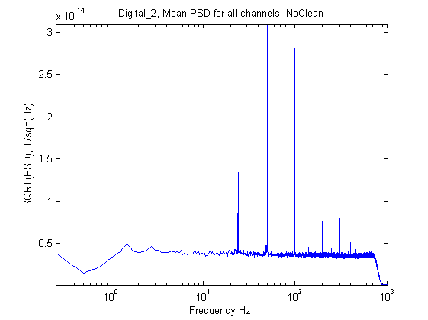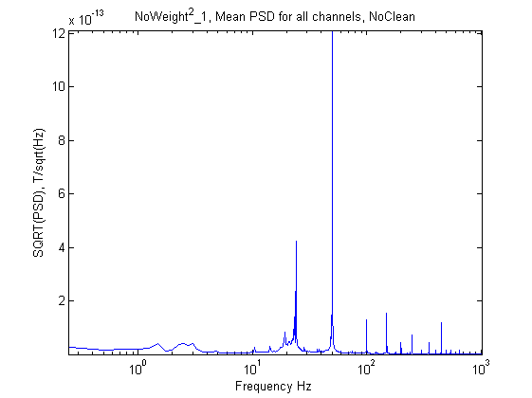
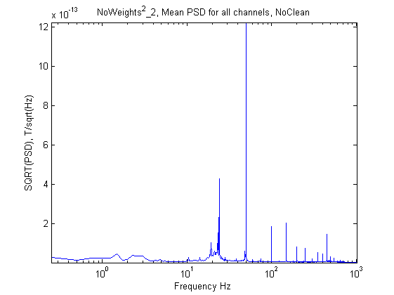

Figure C.1 PSD of data without any cleaning.
See the methods for the various conditions as marked on the titles of the figures.

The first 3 panels in Fig. C.1 and the last two (all recorded with no weights at all) shows that the various conditions has practically no effect on the Line-frequency locked artifacts. In particular, accelerometers on or off or eye-movement camera on or off or its position did not matter.

It also shows that the analog weights reduced the Line-Frequency and 24 Hz artifacts about 10 fold! The digital weights reduced them further about 3 fold.

Cleaning the LF artifacts by software yielded the PSDs in Figure C.2
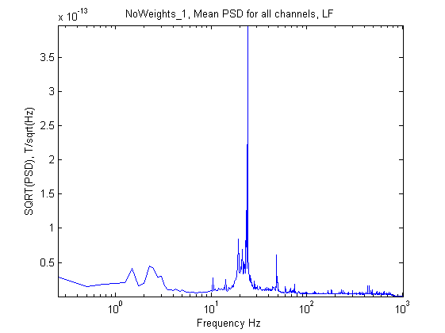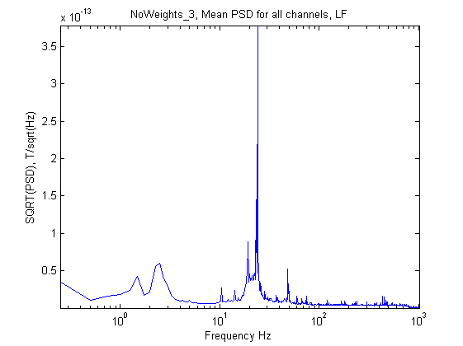
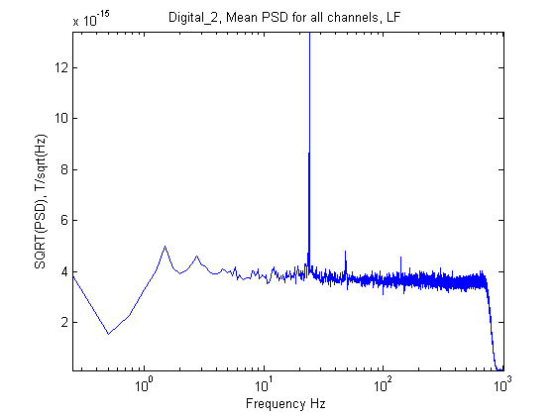
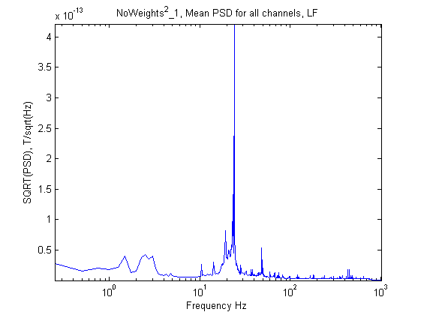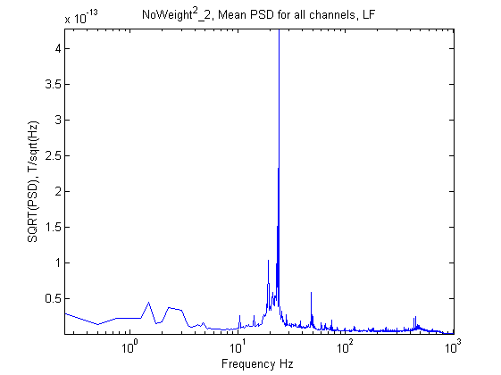

Figure C.2 PSDs after cleaning LF.
Notes: By mistake I did not save the data for analog weights only,but the effect of cleaning LF artifacts there can be seen in Fig. C.4. By mistake the 2-nd figure with 'NoWeigths_3" in the title should read 'NoWeights_5'.

Two points should be noted. When no-weights are used there is an artifact near 50 Hz which is not completely cleaned. The 24 Hz artifacts is about 30 times bigger with no-weigths. There are artifacts in the 1.5 and 2.5 Hz which are about 10 times bigger when no weights are used.

Cleaning the X-Y-Z acceleration with the aid of accelerometers glued to the gantry yeilded the PSDs of Figure C.3
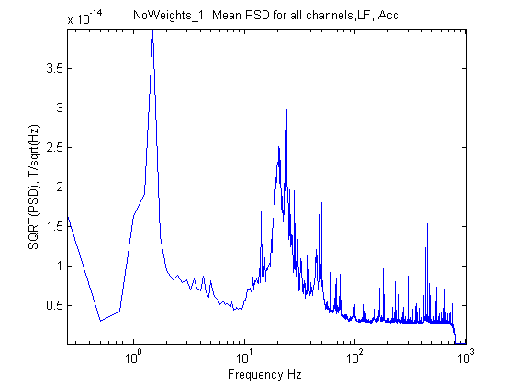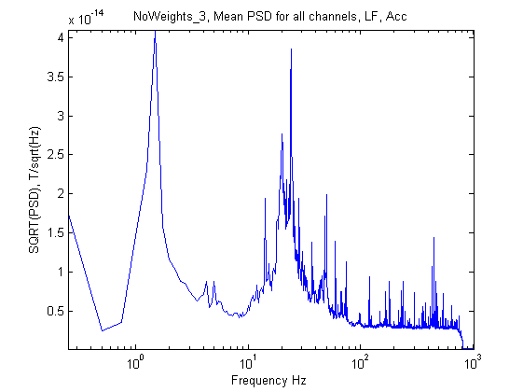
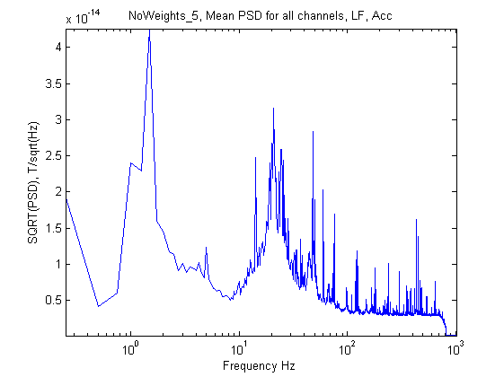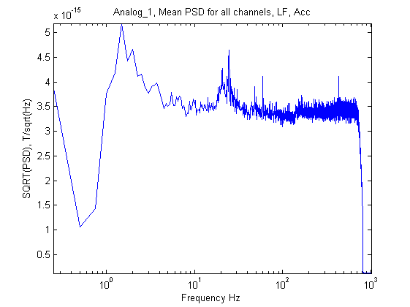
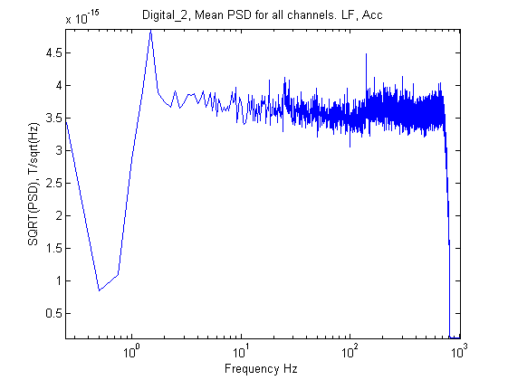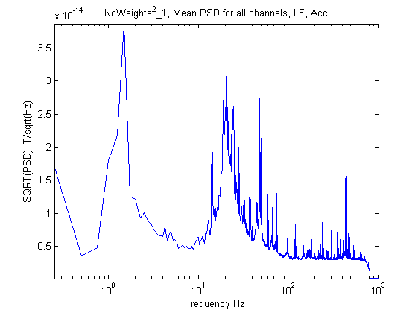

Figure C.3. Cleaning both LF and Acceleration
Note that the Y-Scale is much expanded relative to Figs. C.1and C.2.

With no weights or analog weights only, the acceleration subtraction reduced very much the peaks near 24 and 50 (and possibly also at 2.5) Hz. But there is still considerable peaks near 1.5 Hz (40 pT/sqrRootHz) and around 24 Hz (~30 pT/sqrRootHz). The digital weights enabled complete elimination of the peaks at 24 and higher frequencies. Still there is asmall peak at 1.5 Hz.

Cleaning by FFT yeilded Figure C.4, where Lf, Lf+Acc, and Lf+Acc+FFT are compared.

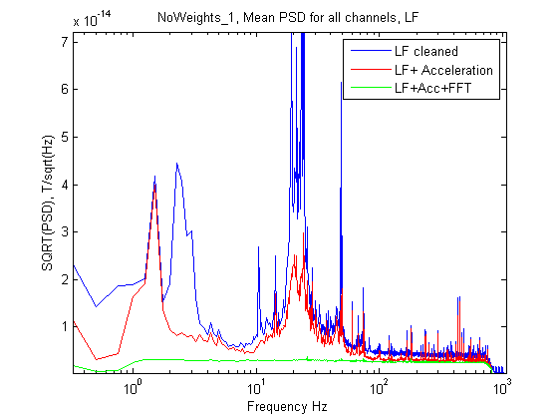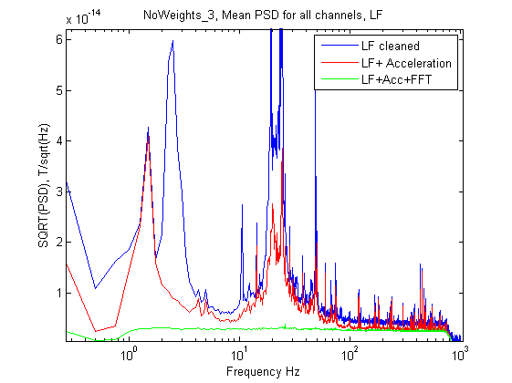
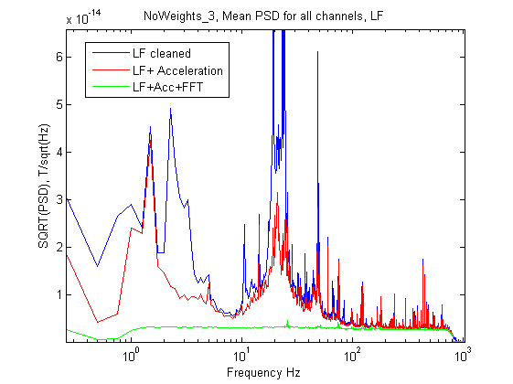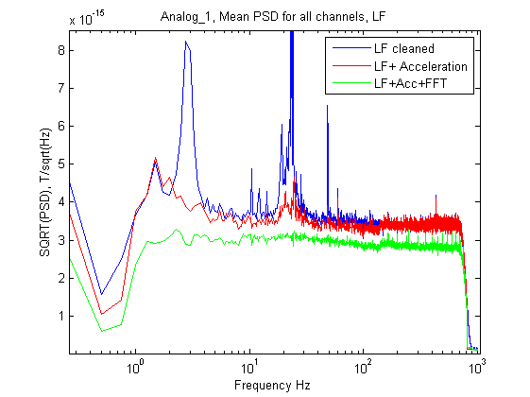
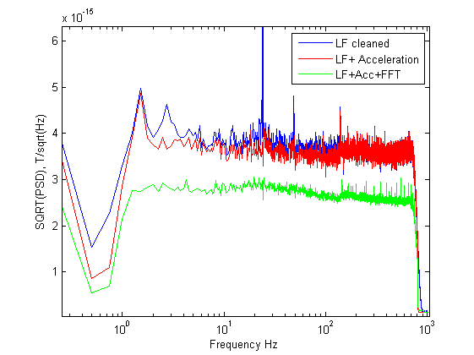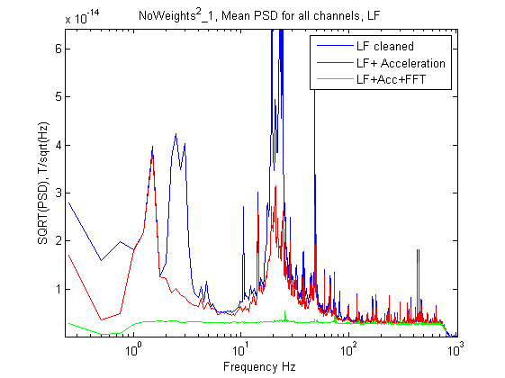
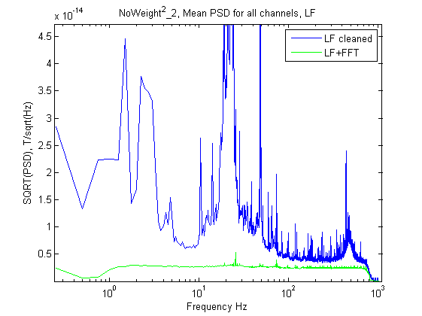

Figure C.4. Comparing the 3 cleaning methods.
The Y-scale is expanded and the peak(s) near 24 Hz are clipped. The different panels have different Y-scales - note that when comparing.
Notes: In NoWeights_2nd_2 (last panel) accelerometers were turned off, so no cleaning by acceleration (red trace) could be done. The title of the digital-weights is missing. The 2-nd title saying 'NoWeights_3' should read 'NoWeights_5.

It is clear that without the analog weights cleaning of artifacts is not complete. They are much better when analog weights are used, but even better when also digital weights are used. The FFT cleaning is much better and not affected by the weights. However (for now) it does not allow source localization.

A comparison with real MEG data is provided in Figure C.5

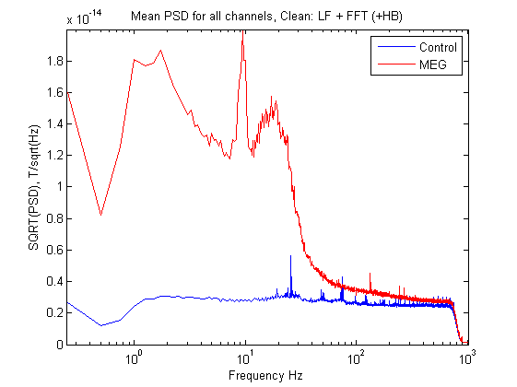

Figure C.5 Comparing clean spectra
Blue - for 2010_10_26/no_Weights_2nd\2 (no acceleration cleaning)
Red - for 2009_11_12
Both cleaned by LF with Adaptive method and FFT with multiple 16Hz bands

Conclusions
- The position and conditions of the eye-tracker and accelerometers do not affect the 50 Hz artifacts appreciably (The EEG probably does).
- Unless FFT cleaning is to be done, both analog and digital weights should be used.

